**Explain the importance of choosing meaningful and descriptive variable names in JavaScript. Provide an example where using a clear identifier improves code reusability?**

Providing a meaningful variable name defines more readability and understandability about the variable.

They are used to store the data and to understand the data.

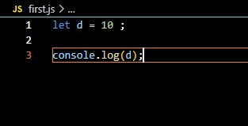

In the above code, variable ‘d’ is declared with a value of 10. And it has no meaning by declaring.

In the real time, declaring a username with a variable has no meaning, It is not much readable.

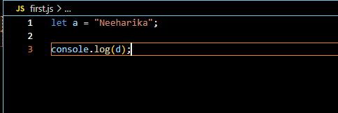

In case of, in real time project environment, declaring a variable with meaning is important.

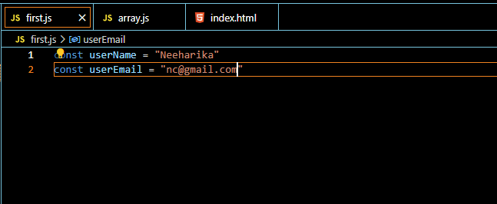

Here, variable name is declared as **userName.** It has more meaning that we are declaring a variable with userName and userEmail.